**INB 372 Project Documentation**

**Illusive Men**

Android Smart Watch Platform

Contents

Carer Application 2

Main Menu 2

Patient’s Location 3

Creating Geofences 4

Geofence Modification 5

Geofence Notifications 6

Panic Notifications 6

Timeout Notifications 6

My Patients 7

Patient Profile 8

Patient Application 9

Main Menu 9

Panic State 10

My Location 11

Memory Game 12

Patient Information 13

# Carer Application

## Main Menu

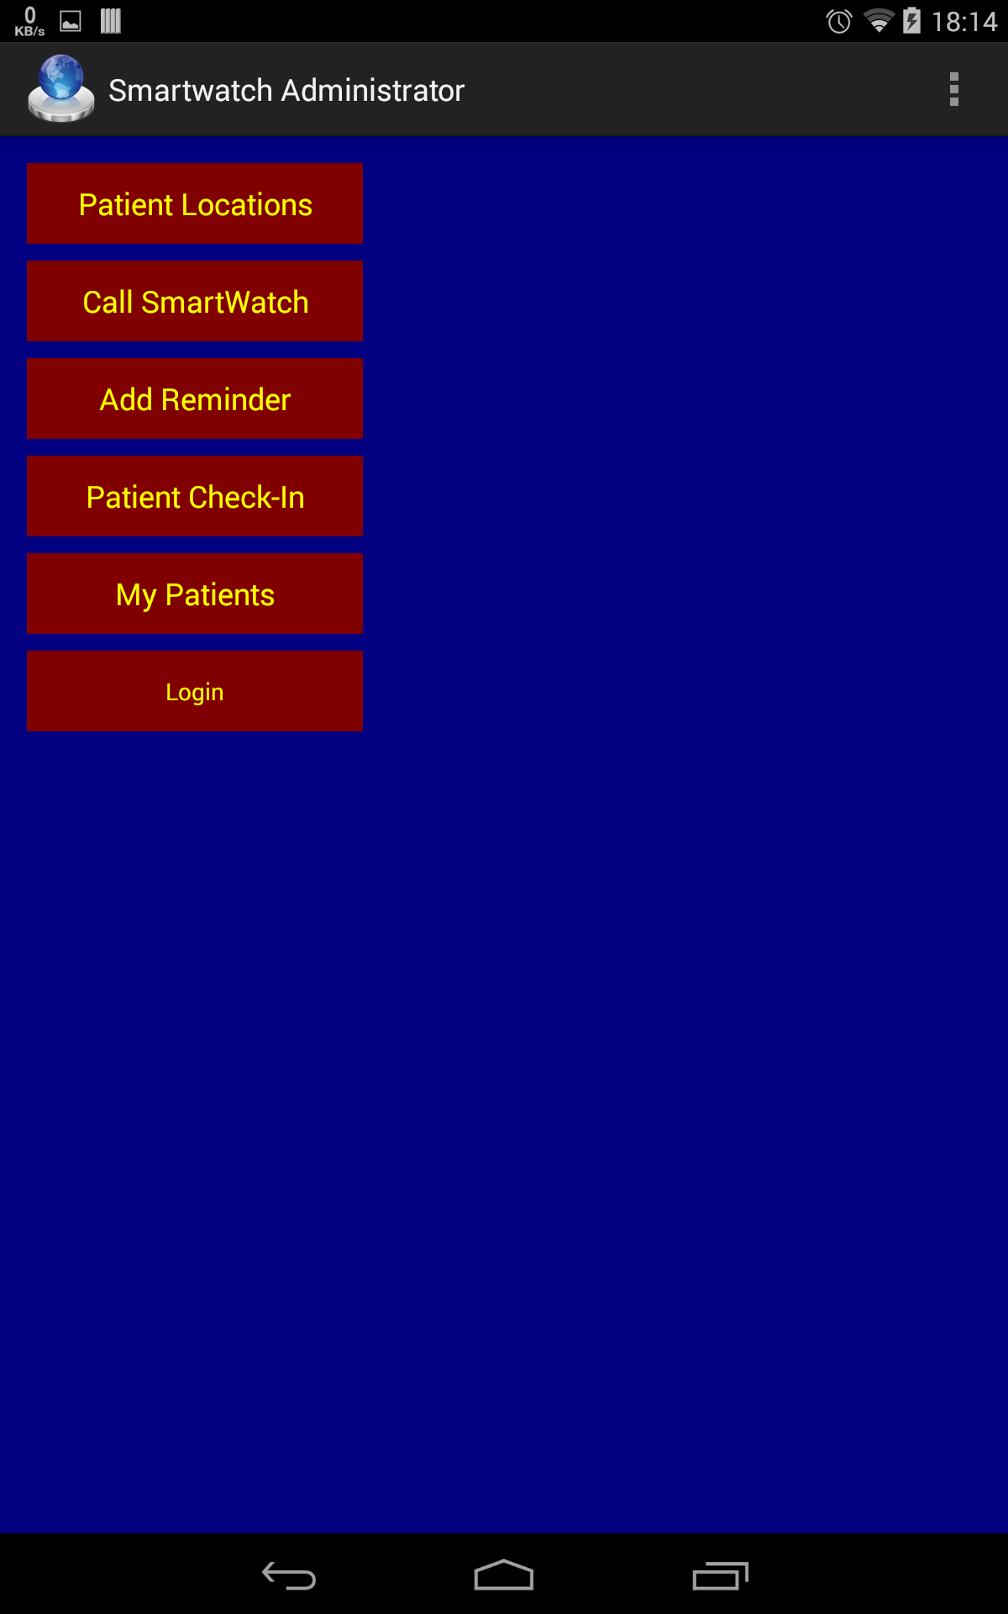

The main menu gives access to all the features of the carer application.

## Patient’s Location

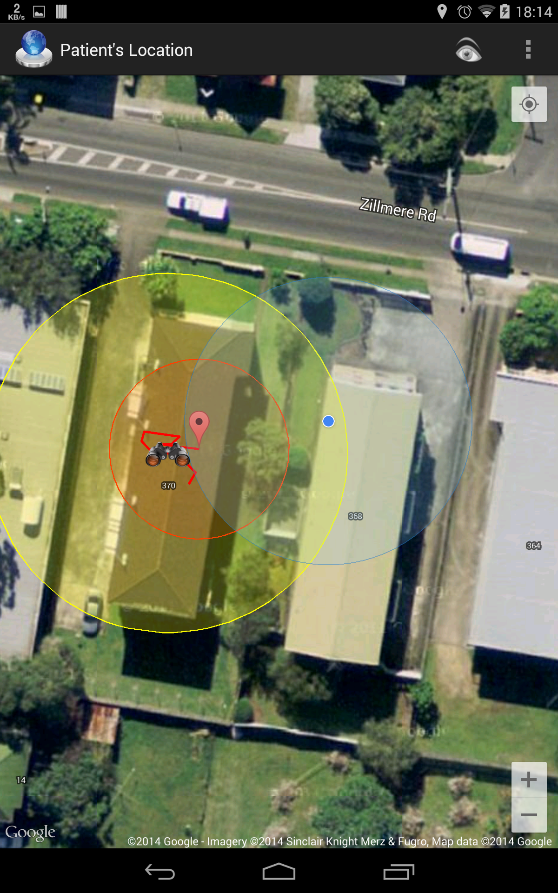

The patient’s location is available via the "Patient Locations” button on the main menu.

Pressing the eye button at the top keeps the patient’s location in the centre of the screen and prevents the screen from dimming to make tracking easier even while moving or doing something else.

Geo fences are displayed by a binoculars icon and a yellow area. Patient position is indicated by a red marker and a red area. The red area indicates where the patient is most likely to be in (with 68% confidence).

## Creating Geofences

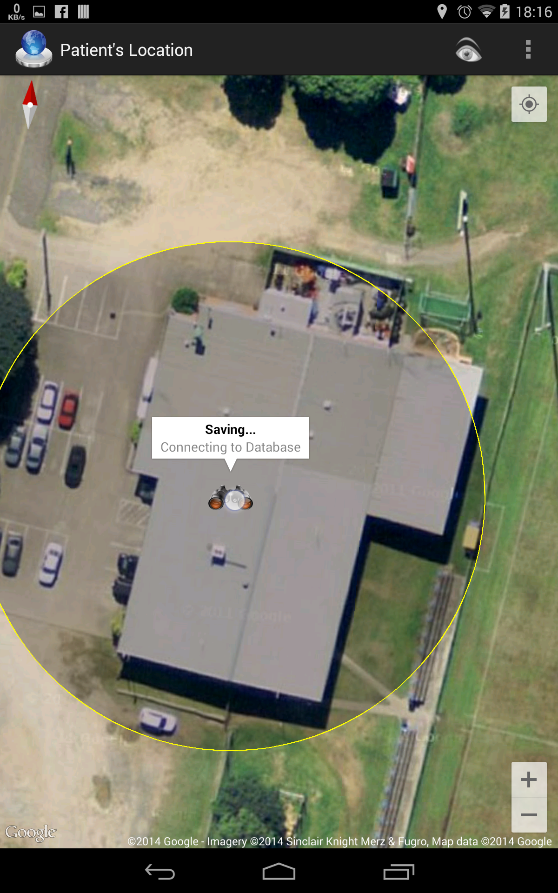

Geo fences are created by long pressing a position on the map while in the “Patient Locations” view.

The fence will first appear with a grey area but once saving to the database is complete, the geo fence will turn fully yellow.

## Geofence Modification

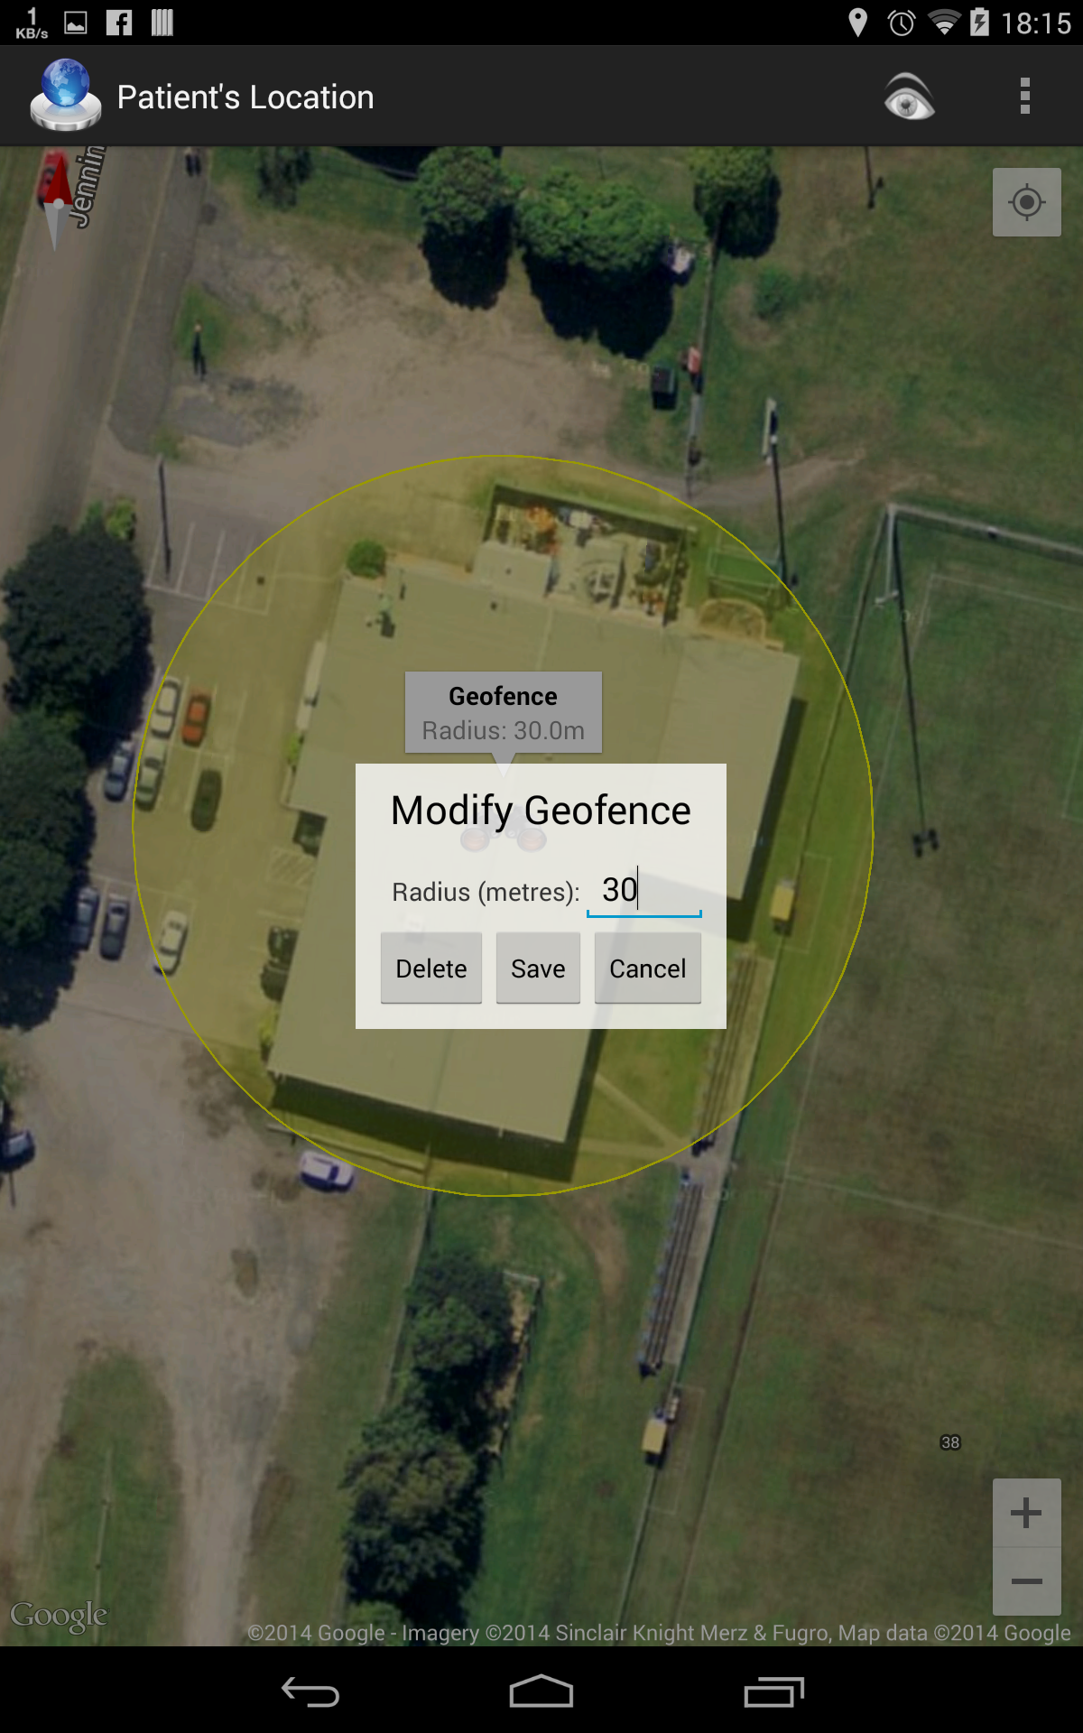

Clicking on the geo fence title (visible in the background) will show the modification options.

The radius can be changed and the fence can be deleted. Pressing delete or save will make the geo fence grey until the operation has completed.

## Geofence Notifications

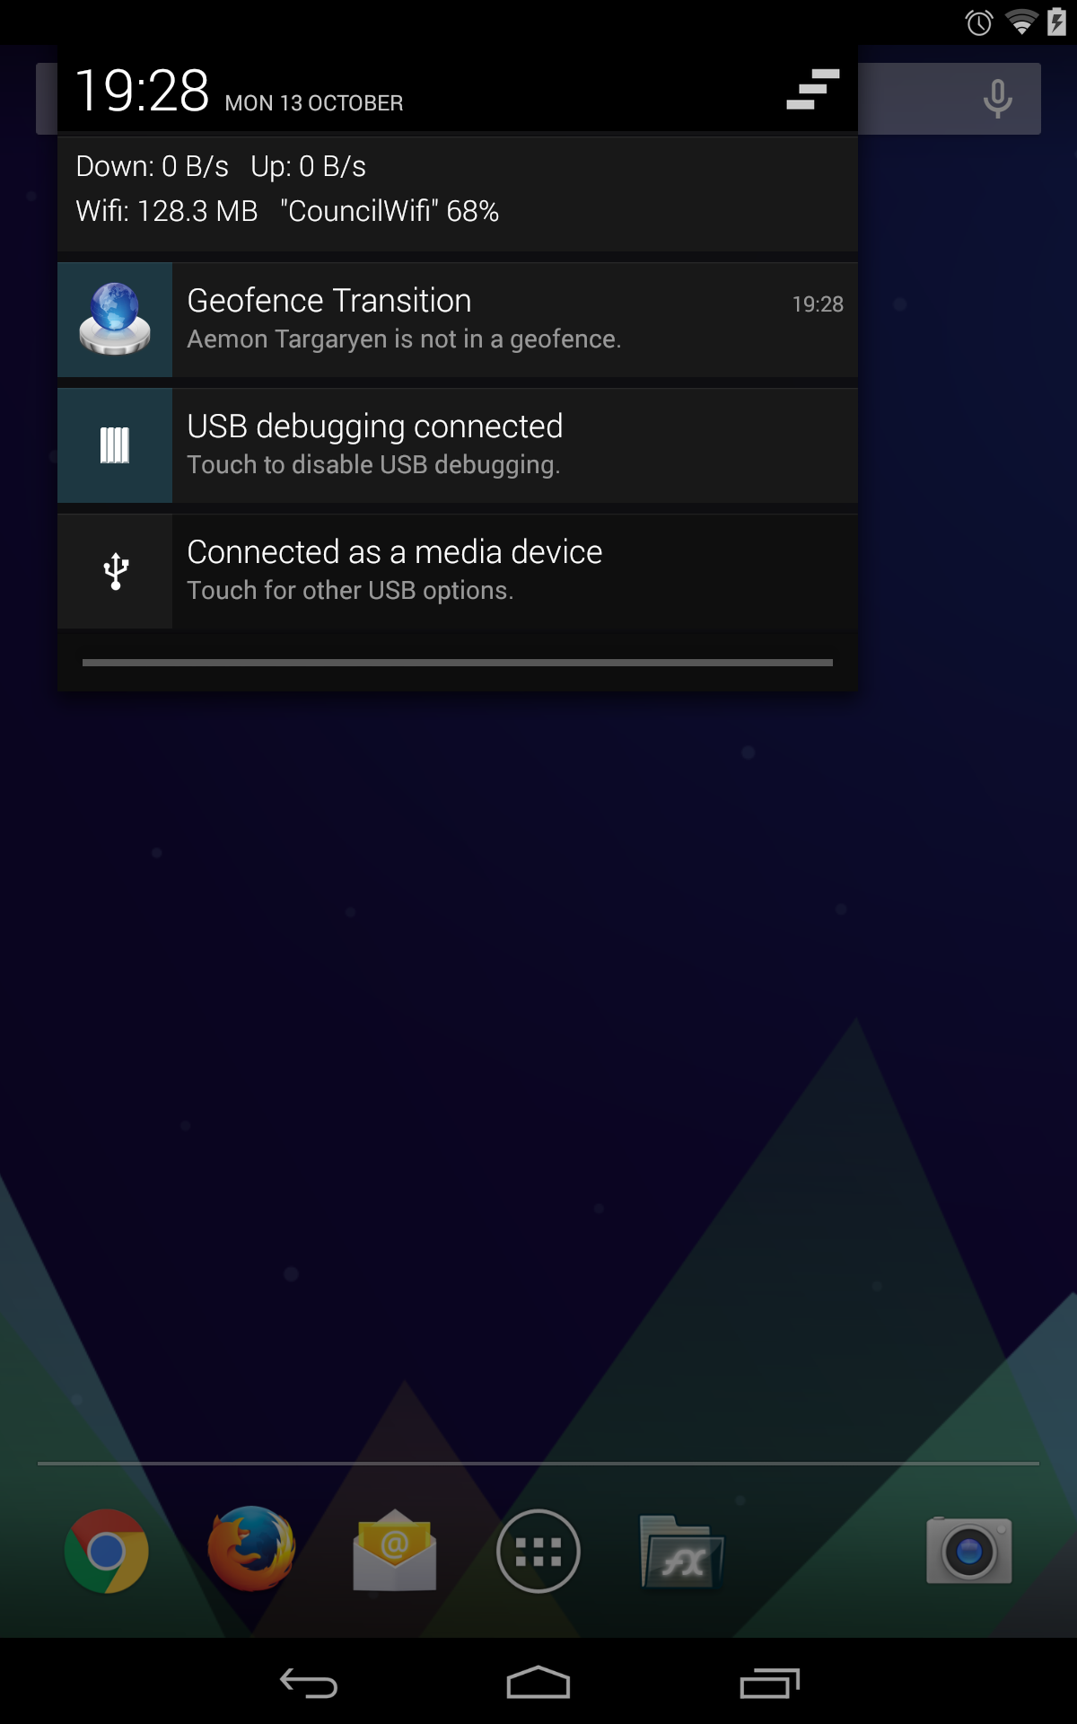

When a patient that was within a geo fence before now isn’t (the red area doesn’t overlap with a yellow area), a notification is shown for a carer and plays the voice “A patient has left a geo fence”. Pressing the notification will open a the map with the patient’s location shown.

## Panic Notifications

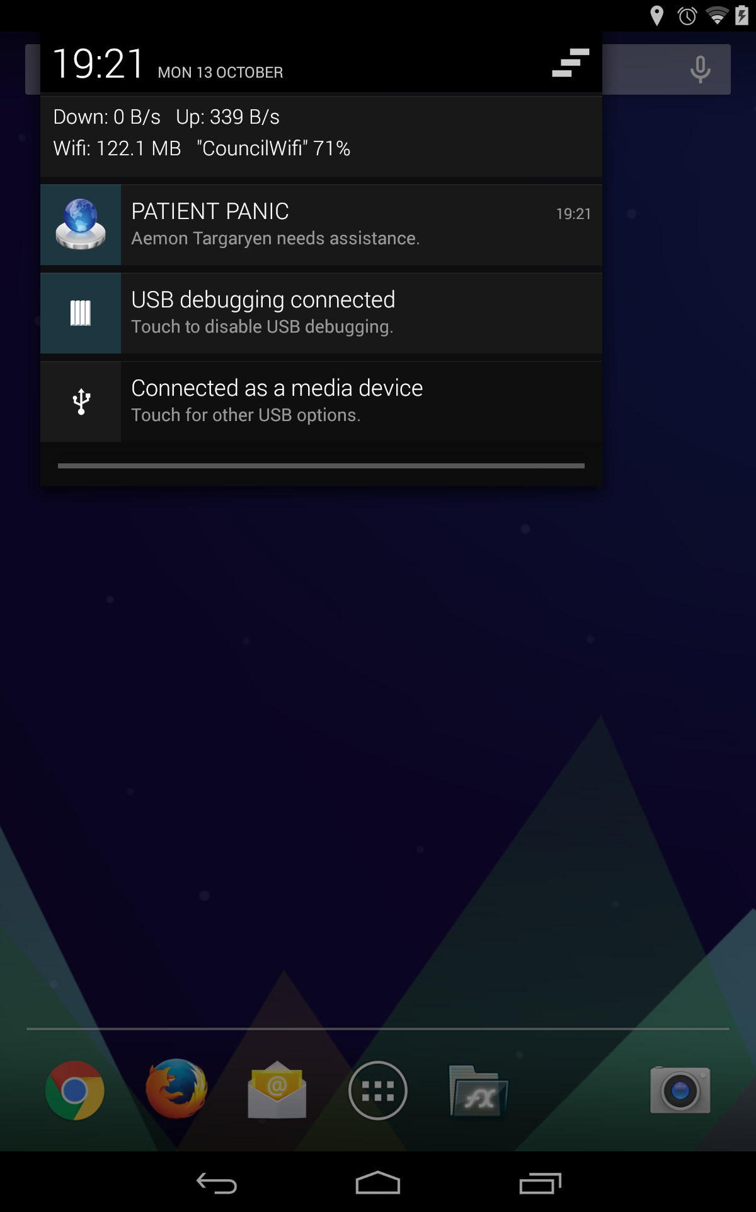

If a patient enables the panic state, the carers will receive a notification playing the voice “A patient is requiring assistance” until the notification is viewed. Pressing the notification will open the map with the patient’s location shown.

## Timeout Notifications

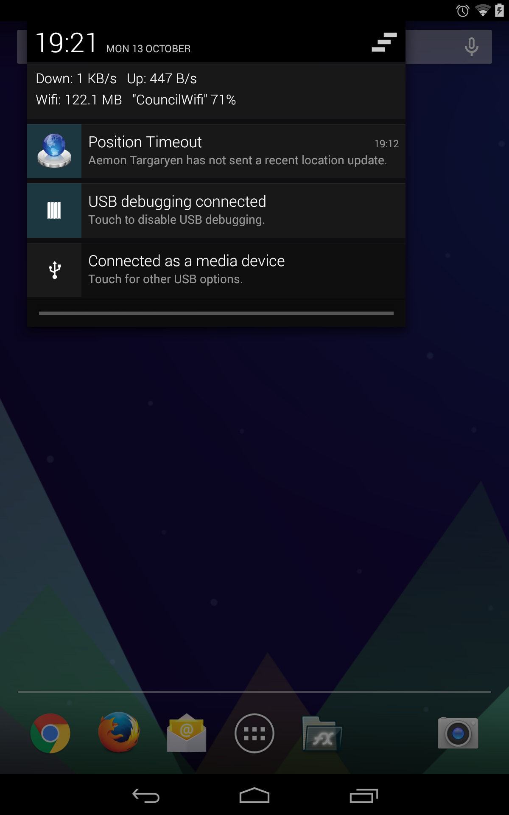

If a patient has not updated his or her location for a set time (5 minutes), a notification is sent to the carers and the voice “No recent location updates” is played. Pressing the notification will open the map with the patient’s location shown.

## My Patients

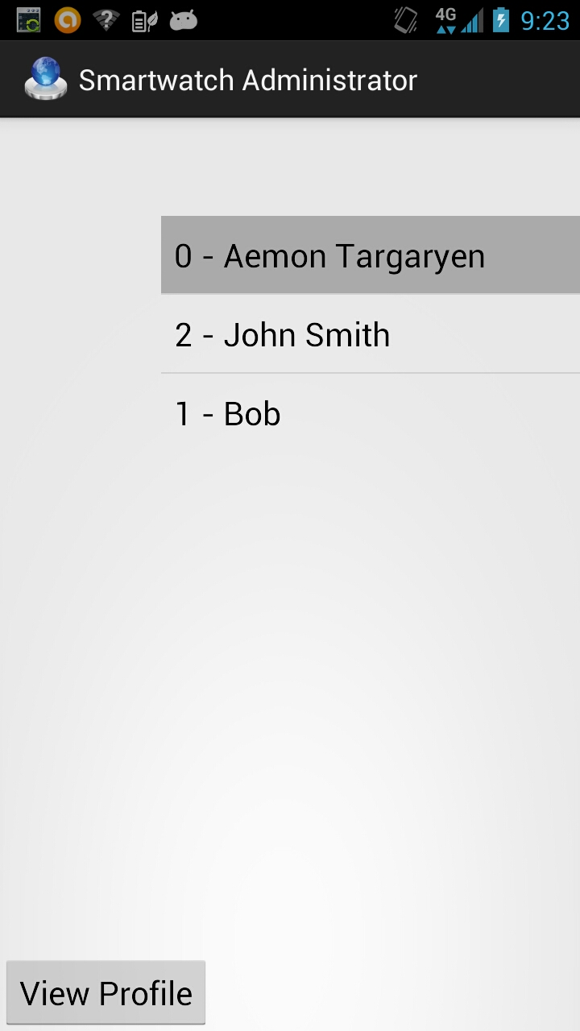

Opening ‘My Patients’ from the Main Menu will present the Carer with a list of their assigned Patients. From this menu the Carer can select which Patient they want to track.

## Patient Profile

Selecting a Patient and then Selecting ‘View Profile’ brings up the Patient’s details. For the Carer, this information can be edited, as below we are updating the Emergency Contact number for this Patient. Once a field has been changed, simply click ‘Save’.

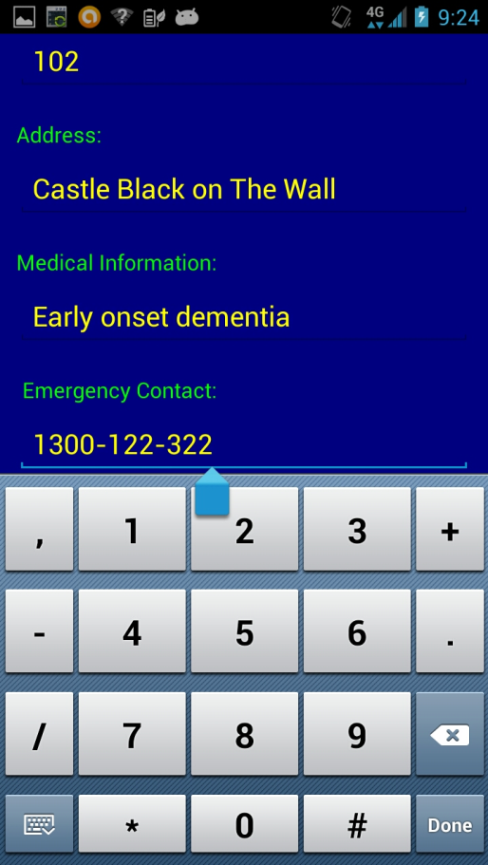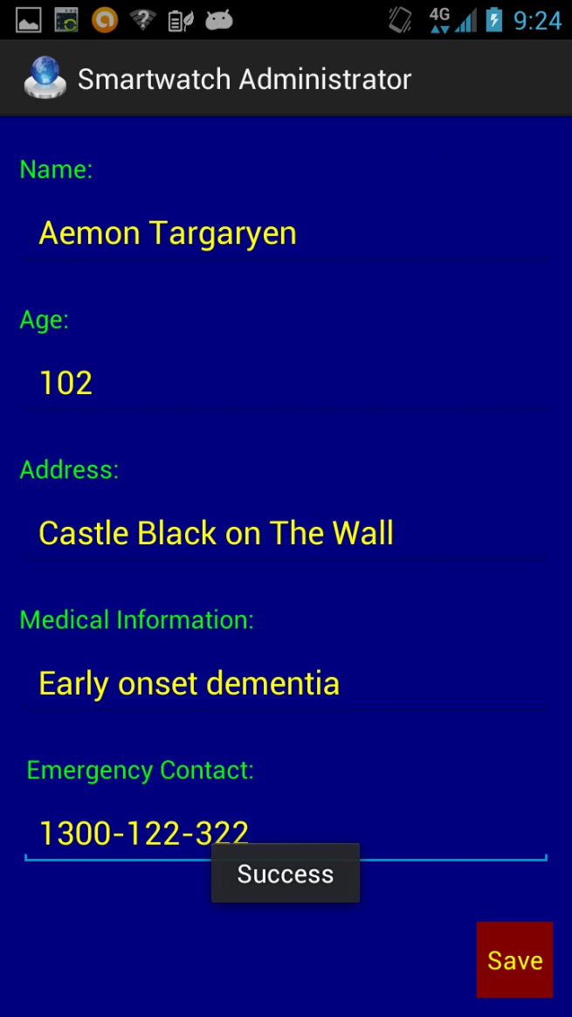

# Patient Application

## Main Menu

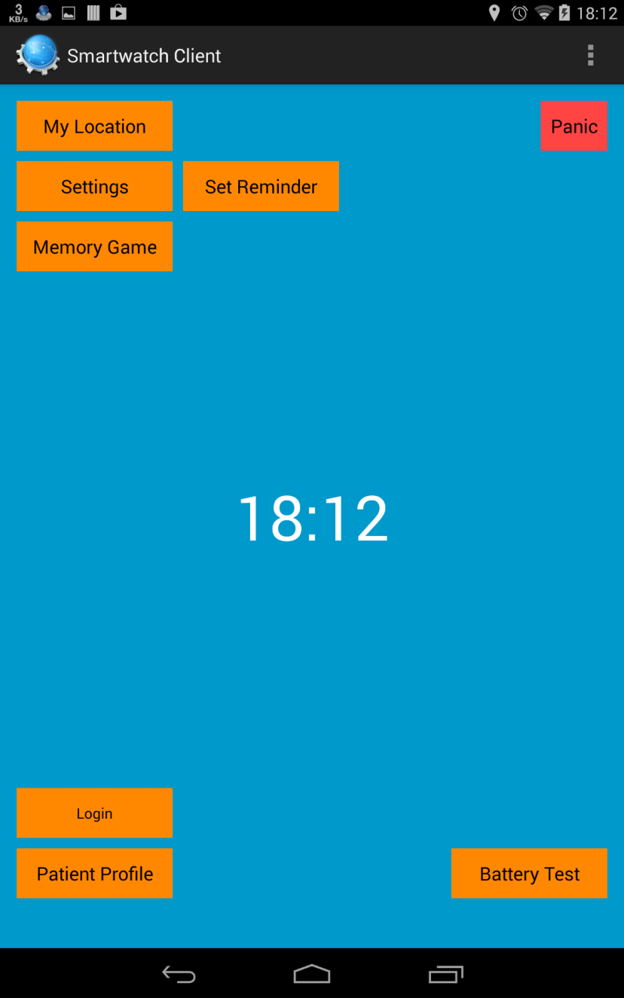

The main menu gives access to all the features of the patient application.

## Panic State

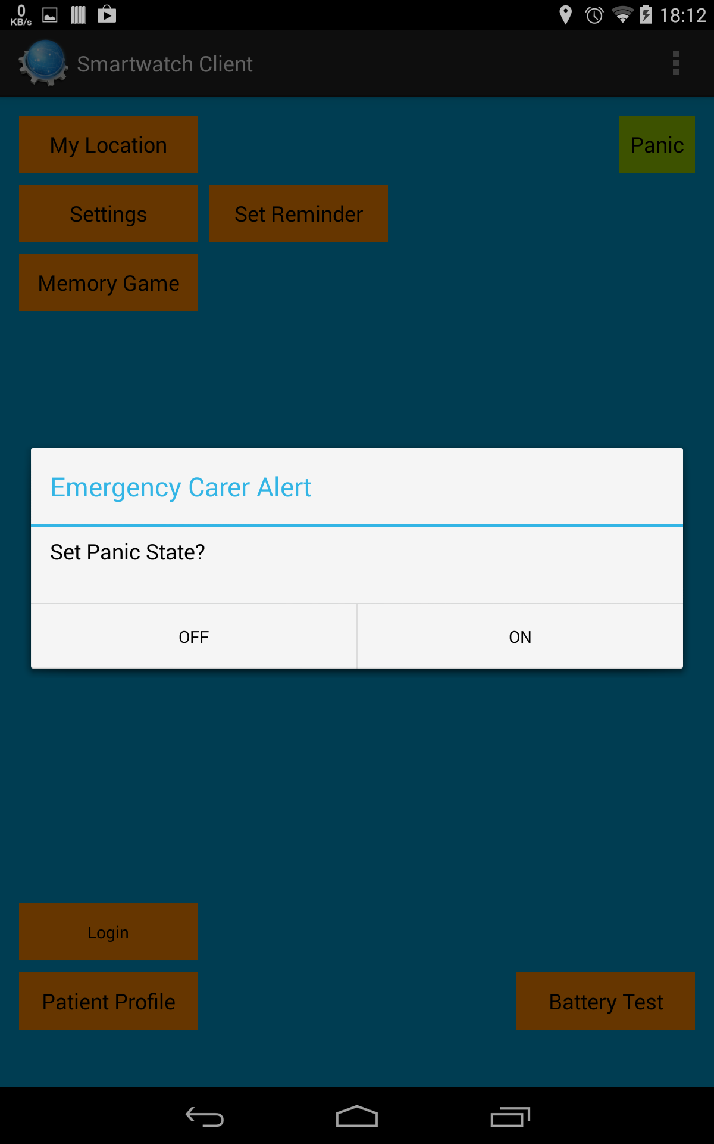

Pressing the panic button allows the patient to seek assistance from carers.

A green button indicates that the patient is fine. A red button allows the patient to see that it has alerted carers.

## My Location

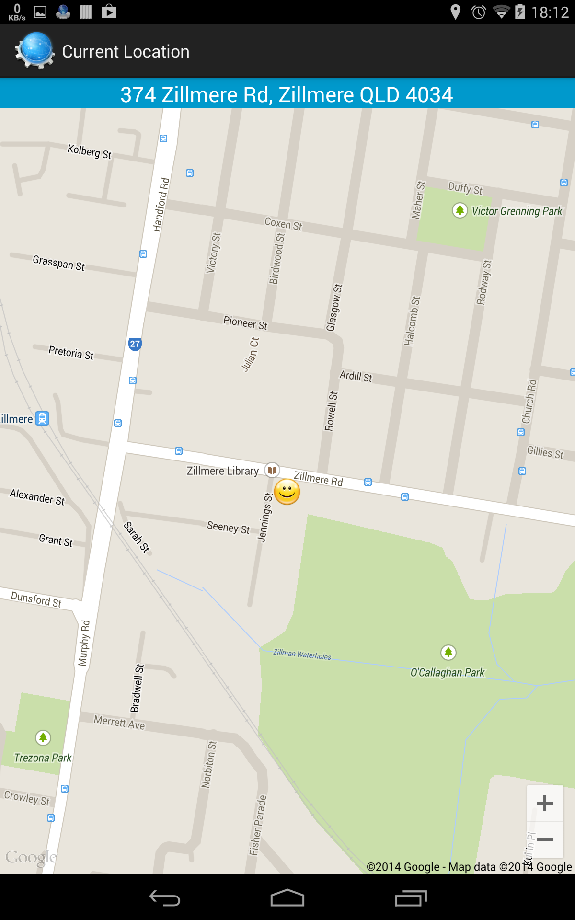

Accessed by the “My Location” button on the main menu. This will display the current location of the patient so they can see, it also includes an address to make describing their location easier to others.

## Memory Game

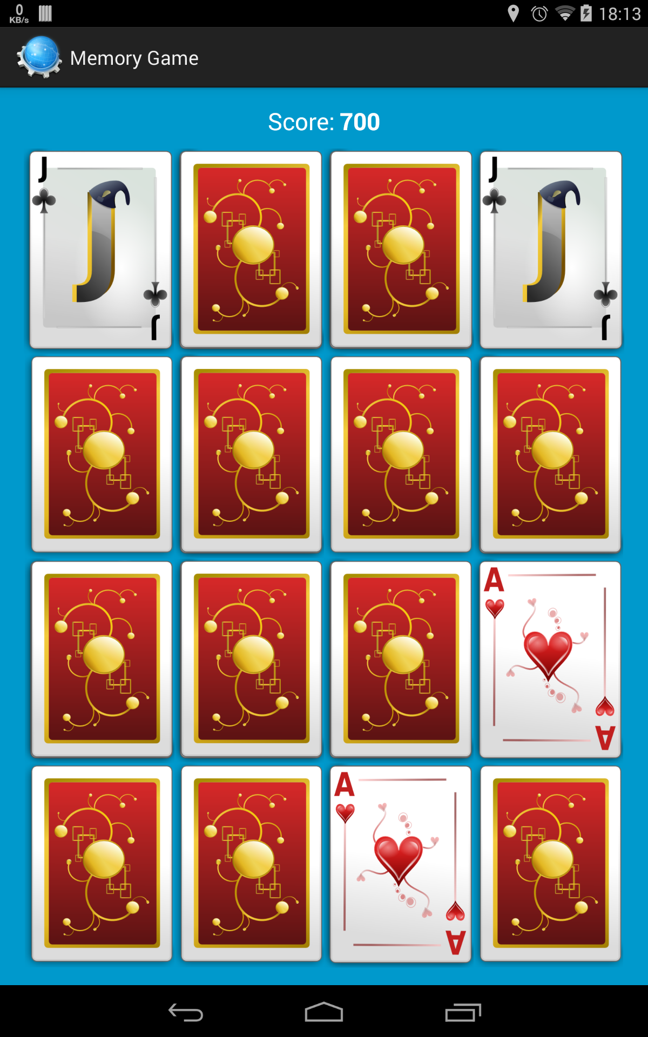

Accessed by the “Memory Game” button on the main menu. The patient needs to make matching pair selections of inverted cards. Points are lost for checking what type of card is at a position and for making a bad selection. Cards are selected by touching them.

## Patient Information

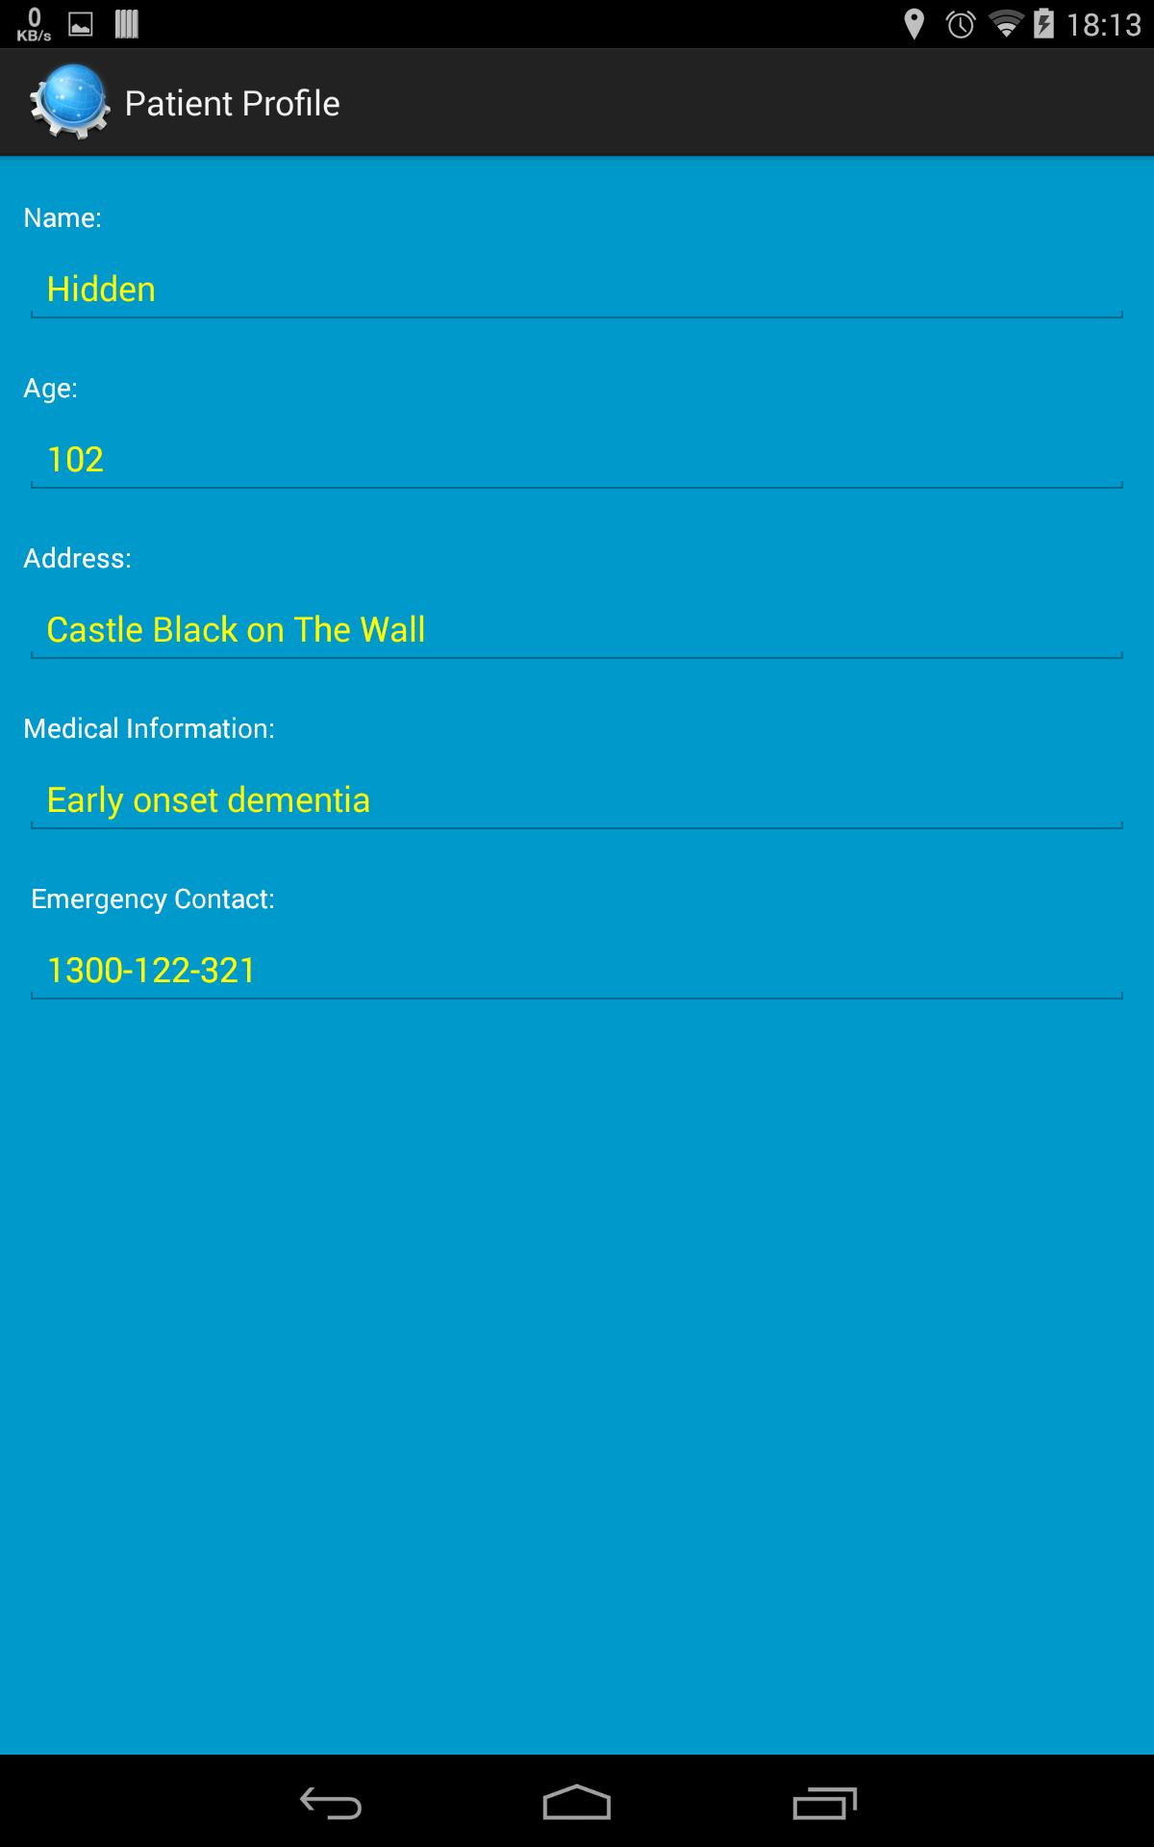

Patient information is visible from the main menu “Patient Profile” button. This information may be helpful if a stranger is attempting to help a patient. Values can be hidden to protect privacy. This screenshot illustrates the name being set to private.